USDS Engineering Take-Home Design Analysis and Implementation
Prerequisites:
- Run on Windows OS.
- Require Java 8 or above.
- Maven build (optional) but provided within the package.
Package Structure:
- apache-maven (given to easy compiling and running the USDS Restful springboot web application.)
- config (containing two configuration files, ecfr.json and usds.json)
- doc (documentation folder):
  - Software Take-Home Design Analysis And Implementation (this document)
  - USDS Flow Chart, USDS Ucases, USDS Sequence Diagrams.
- src
  - main (implementation java classes)
  - test (test java classes)
- mvnRun.cmd, to provide conveniently compiling, testing, and executing the solution based on the apache-maven attached within the package.
- index.html, link to the view / presentation layer of the USDS code of federal regulations.

Design Analysis:
- From the given web services API by the eCFR at https://www.ecfr.gov/. A JSON configuration file, ecfr.json, has been created to containing the overall of all the services currently available at the eCFR API mentioned. The content of the ecfr.json is comprised of an JSON array. Each JSON item in the JSON array, is comprised of the property named “serviceName”, along with the JSON array defined by a tag name “serviceApi”. Each serviceApi item is defined as an JSON that contains only two properties: description (will be used to display the meaning of the service being provided), and api (actual API that will be used to execute using RestTemplate and its result will be accordingly saved to the local file system.), and the localFileName: indicates the local file name will be used to save eCFR data.
- In responding to all eCFR files saved in the local file system in early stage, another JSON configuration file, usds.json, has also been created to containing its content exactly the same as in the ecfr.json. The only difference is the API will only serve using Restful Spring Boot Web Application locally. It will no longer require to go out to https://www.ecfr.gov/ to extract eCFR data because all its services results have been transformed / saved to local file system. LocalFileName value (if changed must be consistently change in both places ecfr.json and usds.json)
Implementation Notes:
- The USDS code of federal regulations, springboot Restful web application, will primarily use the config folder (contains eCFR and USDS json configuration files), folder data (will be created dynamically upon starting up, where all eCFR data queried results will be saved into, need write permission writable), src is where are all my implementation in place.
- To execute and running the USDS springboot Restful web application, simply execute the mvnRun.cmd in windows OS.
- All eCFR API version 1 web services are now transformed into USDS API version 2 and displayed onto the selection drop down to provide user-friendly for the users. The data returned after invoking the API, will be placed into a text area to easy copy and paste along with the capability to search.
- As finding that few API eCFR web services are required to have valid input for the {date} in the format of YYYY-MM-DD as well as the limited of the {title} from [1,50], I provided a way to accept the input for the two values {date} and {title} to easily executed the end point and retrieved its result. If users entered a wrong value for {date} or {title}, errors handling will rely on the eCFR API web services to handle them.
Documentation:
- Software Take-Home Design Analysis And Implementation (this document)
- USDS Flow Chart, USDS UCases, USDS Sequence Diagrams.
Screenshots:
Start Up:
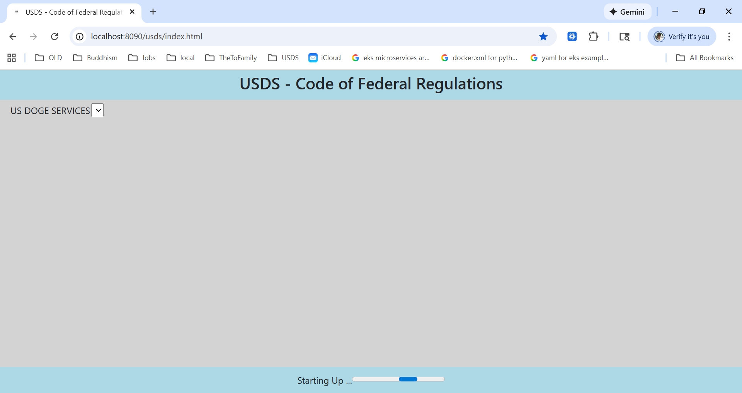
Services Ready:
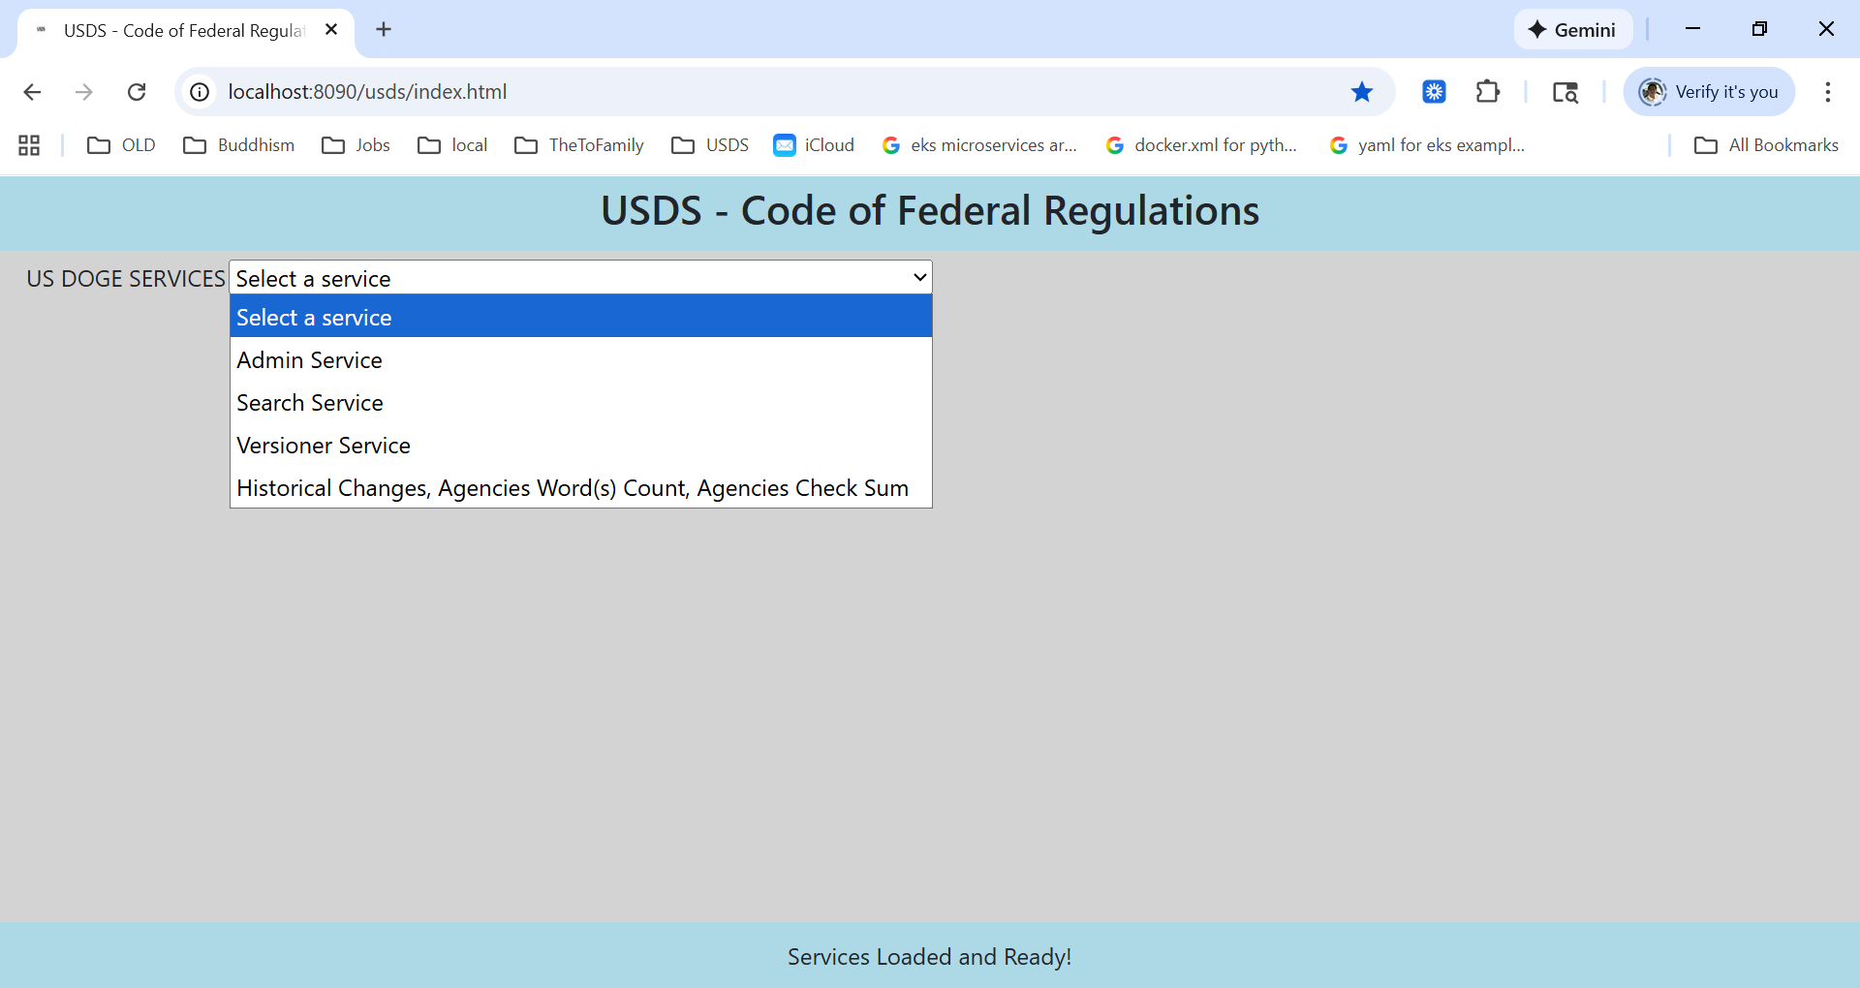
A “search service” selected and corresponding API services shown in the drop down selection box:
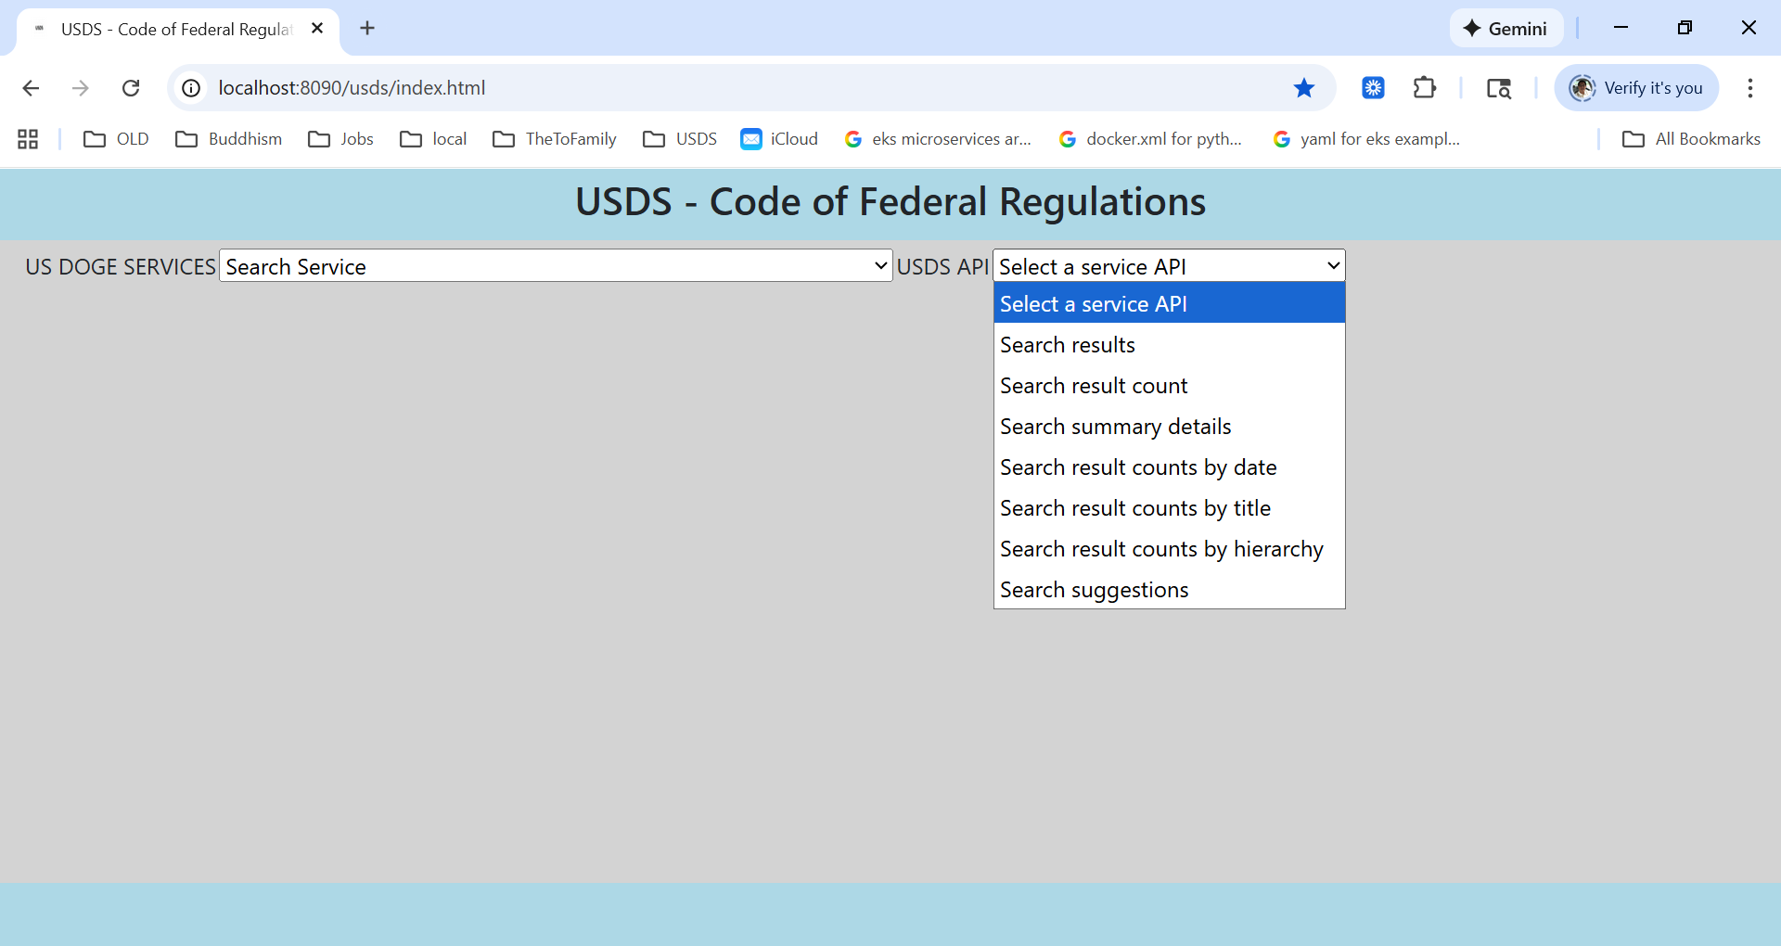
A historical changes over time, words count by agency and checksum of each agency has been selected and upon selecting Run Statistical Report, the data resulting along in the text area.
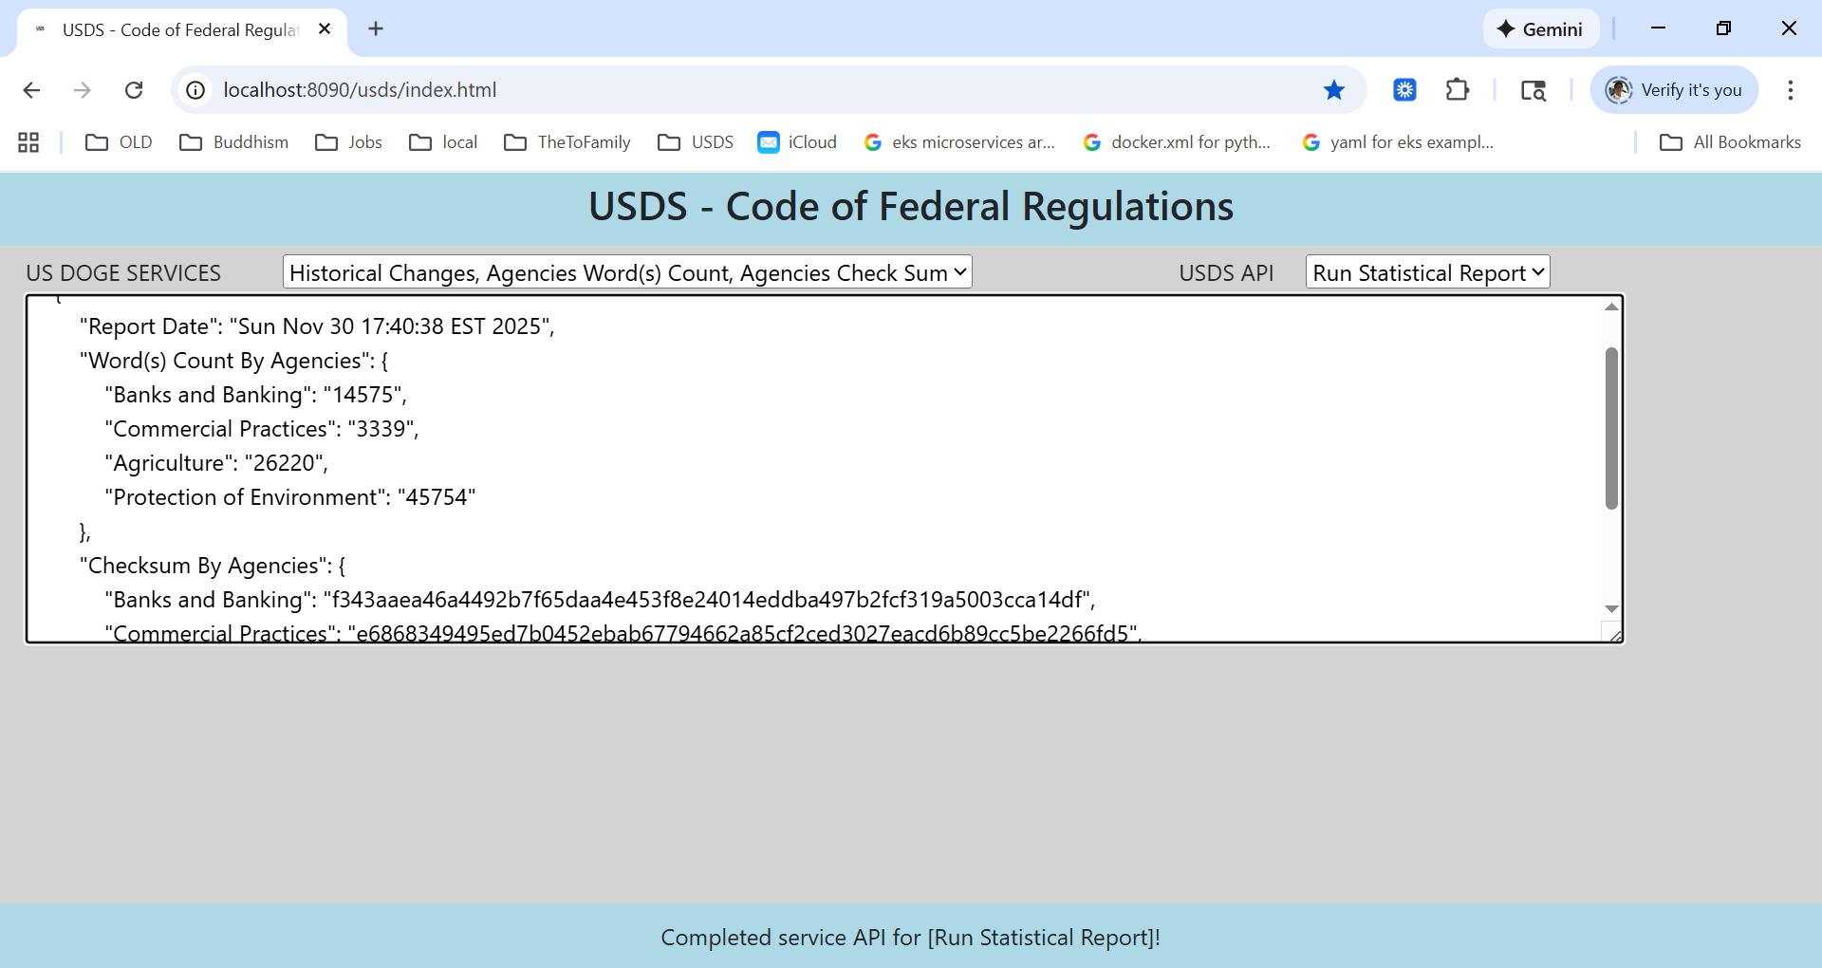
An API service in the form of existing {date} or {title} from it, the USDS is now allowing users to enter as much as they want for a batch of hyper-links to be executed independently by the values they entered:

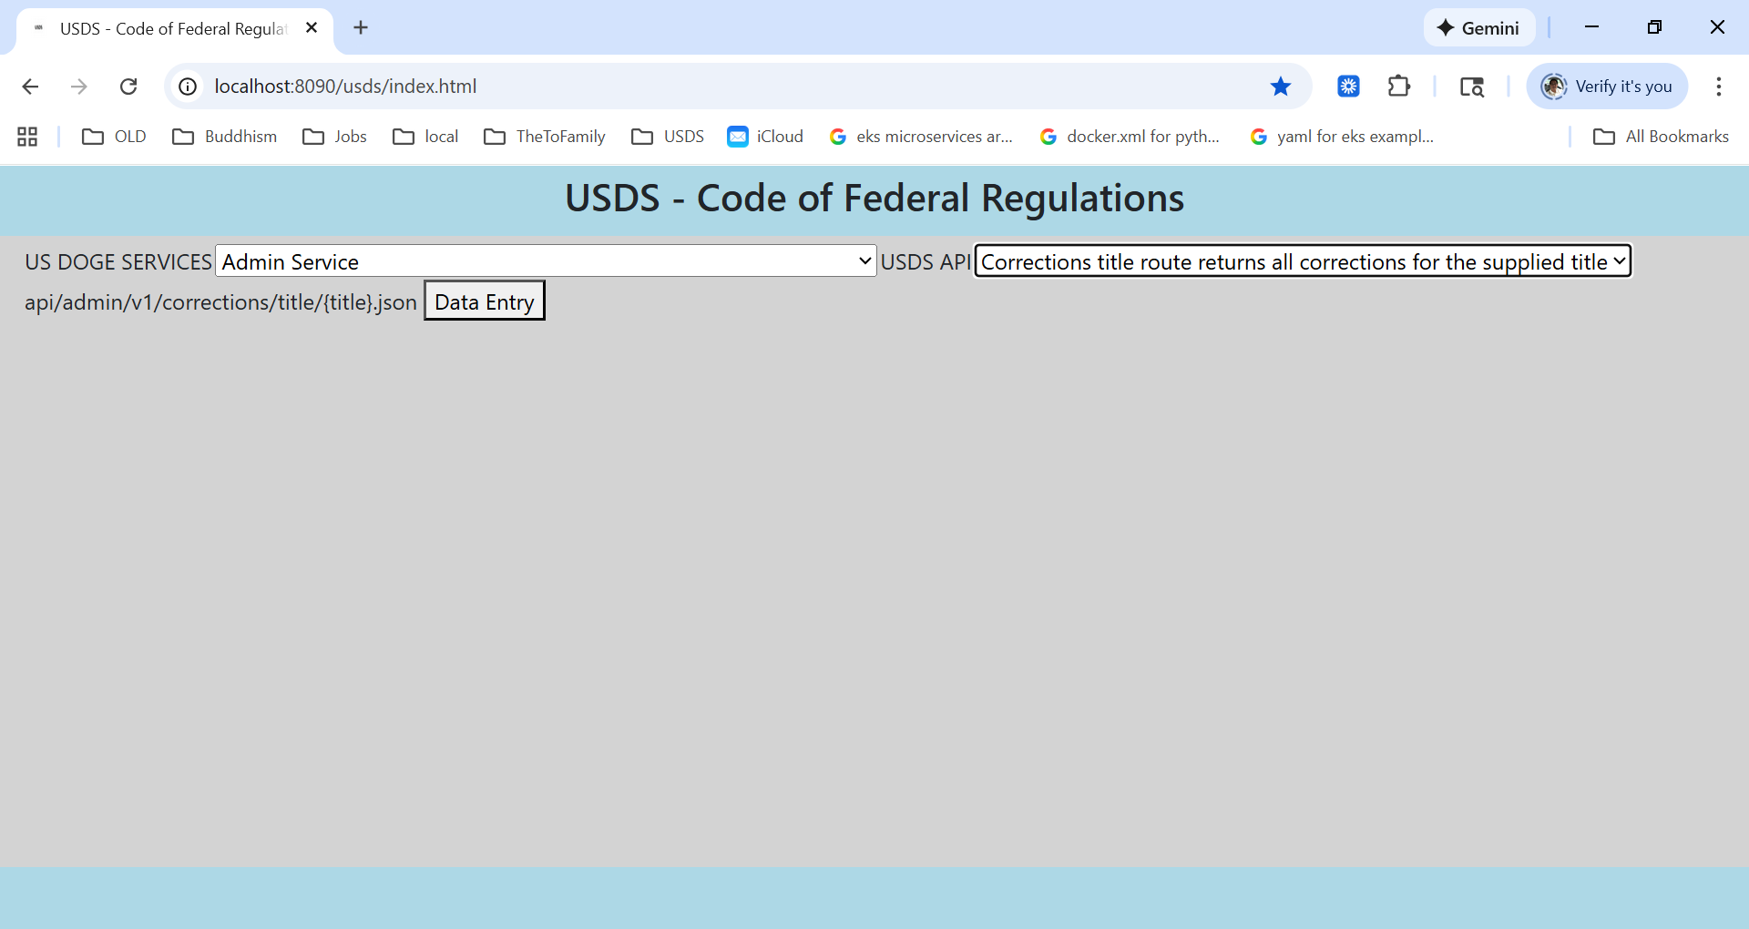
An API service in the form of existing {date} or {title} from it, the USDS is now allowing users to enter as much as they want for a batch of hyper-links to be executed independently by the values they entered:

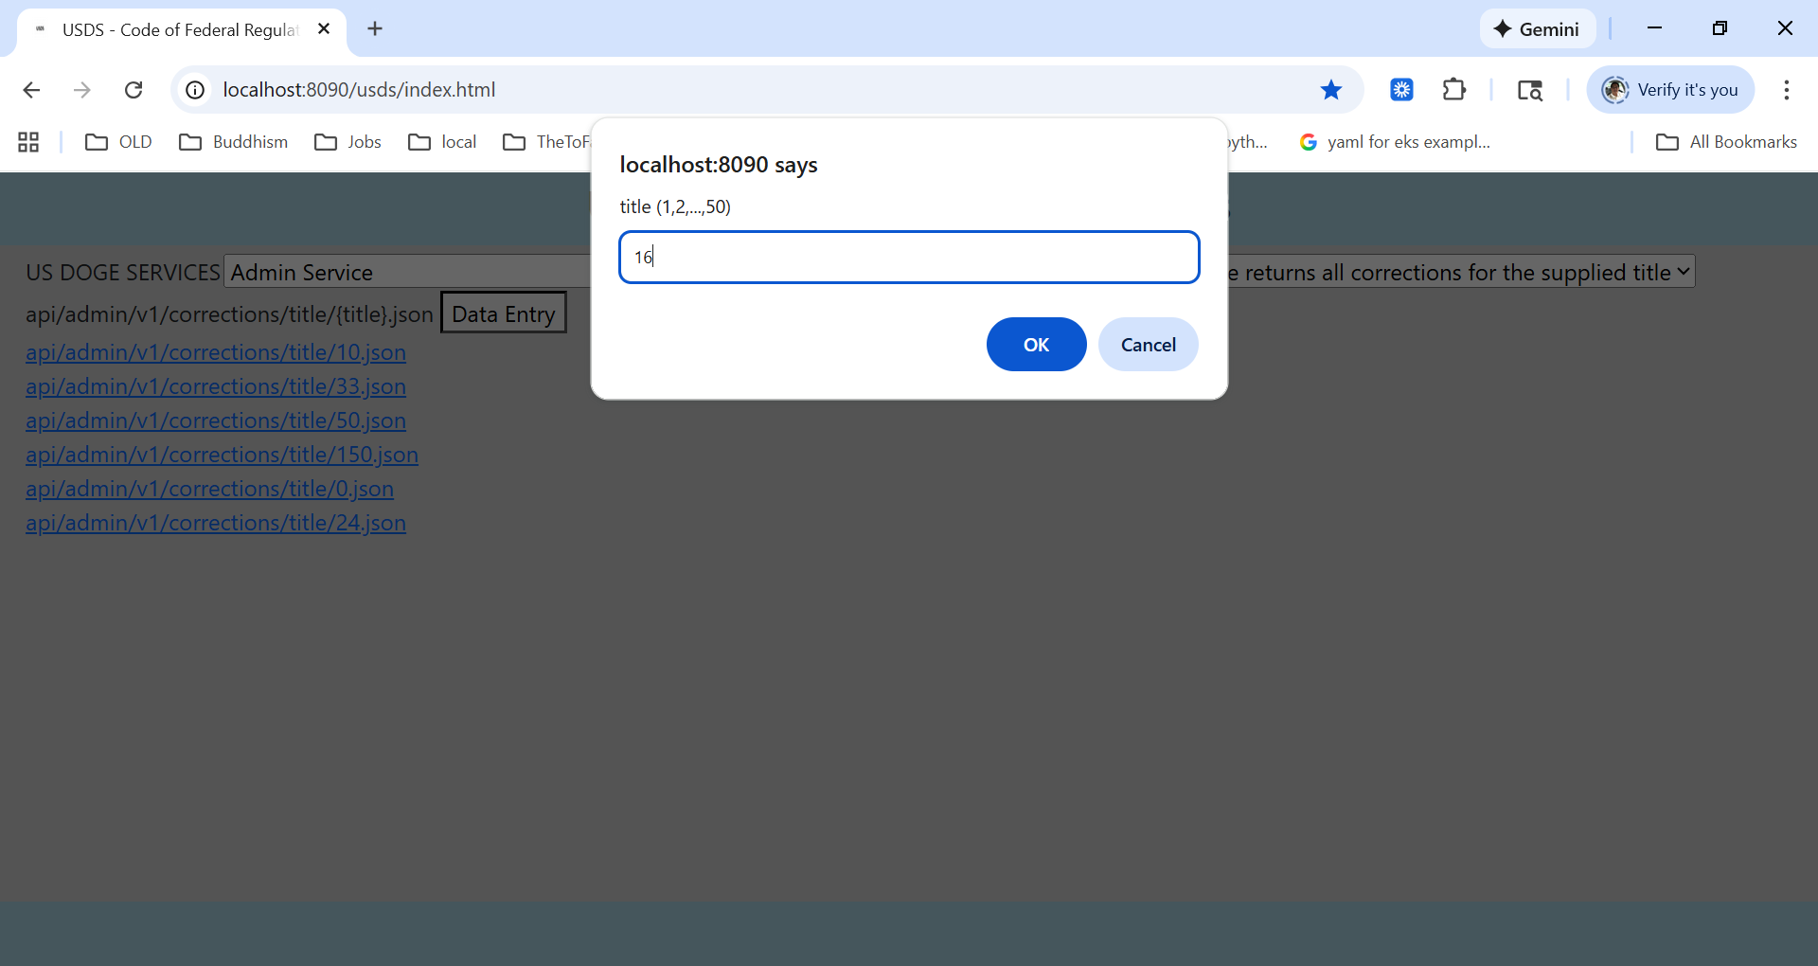

The {date} or {title} or both existing after having their value executed in different tab or new browser window:

